# AN Tracker Mobile UI Requirements

# Preface:

This is the requirements document for AN Tracker Mobile UI. This document provide the guidance and suggestion for development of andriod mobile app. The mobile app will only store data locally (on phone memory) which is required for interaction with backend. The backend of this app is cloud based service which will be available through REST API.

**Please make sure to go through the UI Design Principal to understand the overall requirements.**

**The priority of the work in terms of UI develoment currently is to develop – all “create” related screens. The “view or list” screens may change.**

# UI Design Principal

* UI will be kept simple by showing only required field for creating various objects, if user want to add more details he can click on “Advanced” or similar link/button on the form.
* Frequently used data (e.g logged-in employee-id) will be stored in the mobile cache. The details given in the next section.
* Wherever date is applicable show the calendar menu and also populate the current date for data entry ease.
* All the UI labels/messages prompts should be internationalized, i.e. the UI should support multiple languages and for that, instead of actual label/message, a key will be used as a placeholders on the forms. The placeholders will be replaced with the language specific transalation.
* The mandatory field on the screen will be marked with *. This is not shown in the wireframes (mock screens given the document) .
* The field validation related errors/warning message should be shown inline with the field itself.
* The successful creation/failure (e.g Employee created successfully) message can be shown on the top of the form.
* Please make sure to use spell check during UI development for all menu/error/messages

# Following Items will be cached:

|  |  |
| --- | --- |
| **Important / Global Object** | **Description/Design** |
| LoggedInEmployeeID | * EmployeeID of the logged-in user |
| CreatedById | * Same as LoggedinEmployeeID * Store in the mobile app cache. * Hidden on Mobile UI * Need to pass to almost all API |
| OrgID | * Logged in user’s Organization Id * Store in the mobile app cache. * Hidden on Mobile UI * Need to pass to almost all API |
| City | * List of Cities * Store in the cache |
| Customer/Vendor | * Customer/Vendor accounts which are needed on many screens are cached in the mobile app. |
| ExpenseCategory | * List of Expense Category * It will be cached. |

# UI Forms

## Login

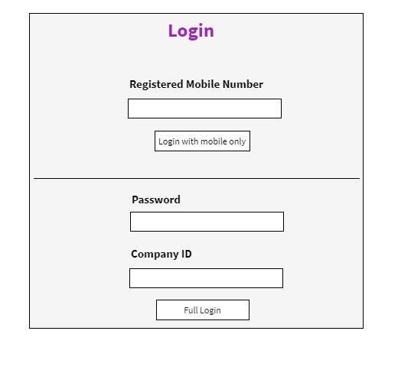

|  |  |  |
| --- | --- | --- |
| **Field** | **Validations** | **On Action** |
| Registered Mobile Number | Not Empty and 10 digit mobile number | Full Login |
| Password | Not Empty |
| CompanyID | Not Empty |

|  |  |  |
| --- | --- | --- |
| **On Action** | **What to do** | **API to use** |
| Full Login | Validate Mobile Number and password is correct for given Company ID |  |

Future Screen (Not to be developed now)

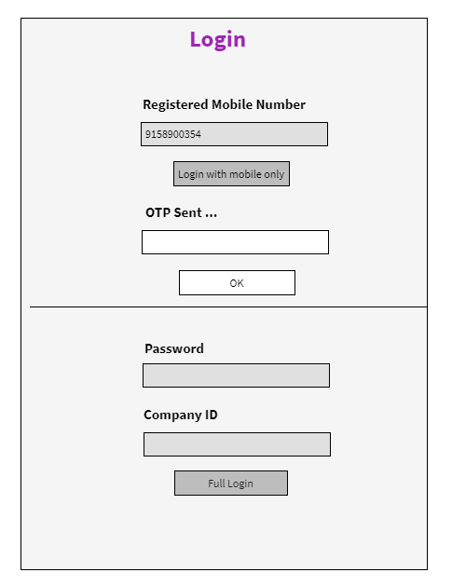

## Dashboard

Special Instuction:

1. All the dashboard items should be developed independently. Meaning in future, we can set visibility for each boxes. The box should be visible to the logged-in user or not.

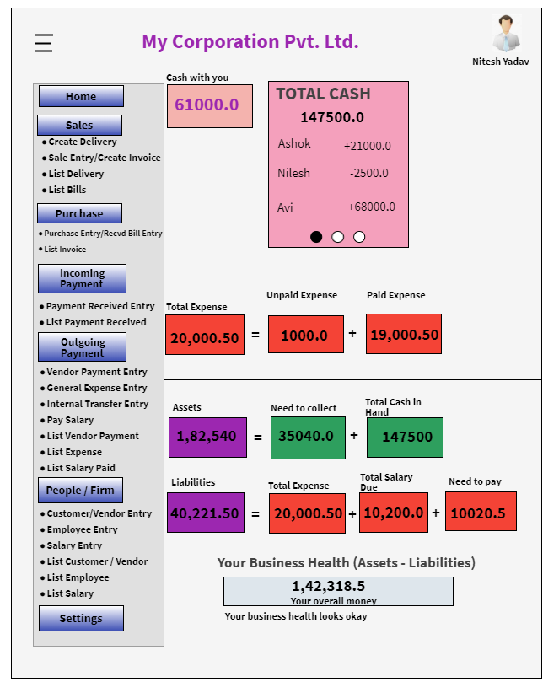

## Create Customer

We will show basic form. If end-user wants to see more fields then he/she can click on “Advanced”. Its basically one screen only but we are not showing all the fields by-default to not to scare the end-user.

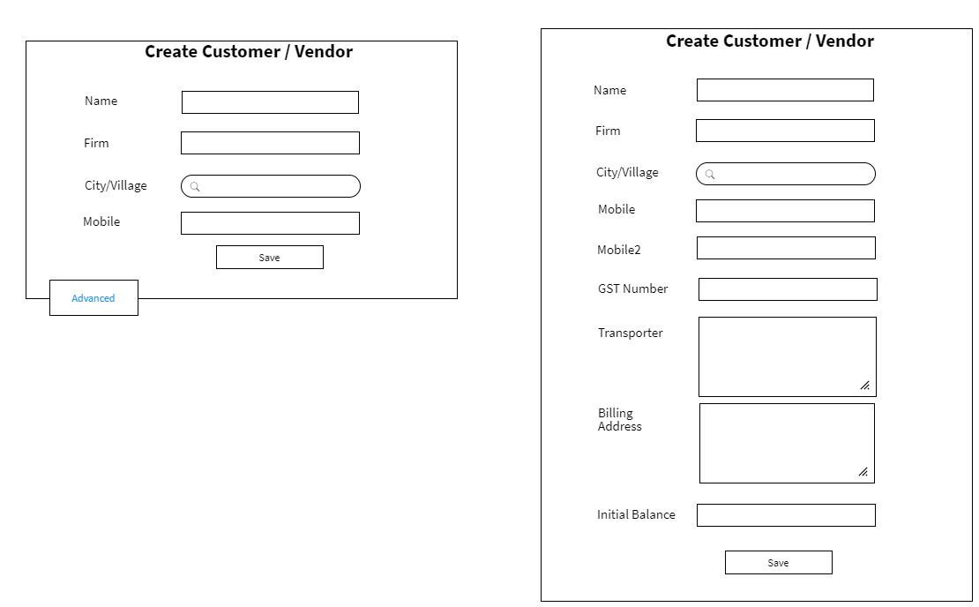

|  |  |  |
| --- | --- | --- |
| **Field** | **Validations** | **On Action** |
| Name* | Not Empty – atleast 2 characters | Save |
| City/Village * | Not Empty  Auto Type Search – after two characters |
| Mobile Number* | Not Empty – 10 digit number |
| GST Number | 15 character |
| Mobile2 | 10 digit number |
|  |  |

|  |  |  |
| --- | --- | --- |
| **On Action** | **What to do** | **API to use** |
| City/Village  Type 2 character – auto search | Search City/Village from the list |  |
| Save | Create Customer |  |

## List Customer/Vendor

Full Form will look like following:

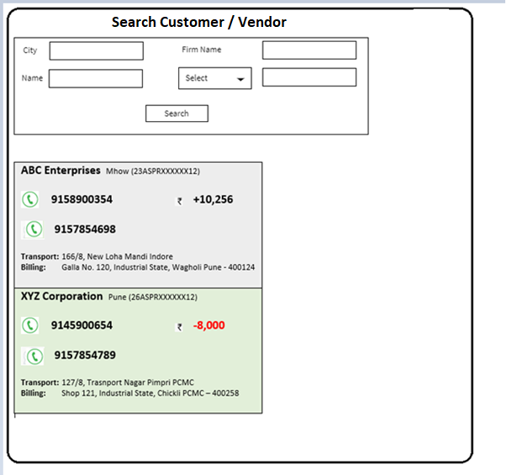

**Search Panel explaination below:**

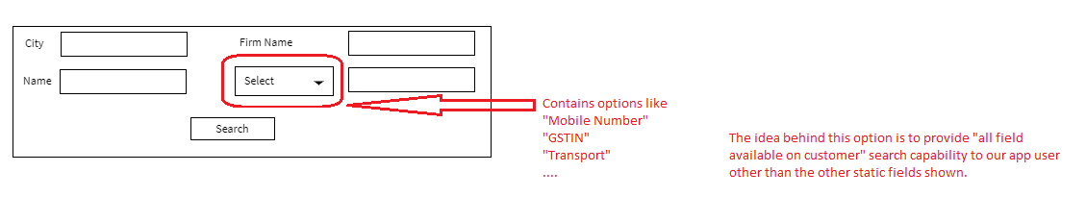

Notes:

If you look at the “Select” field, it gives user a choice of selecting other fields which are not directly available statically. Instead of making all fields “statically” available, here in future we can add more fields.

**List Panel Explaination below:**

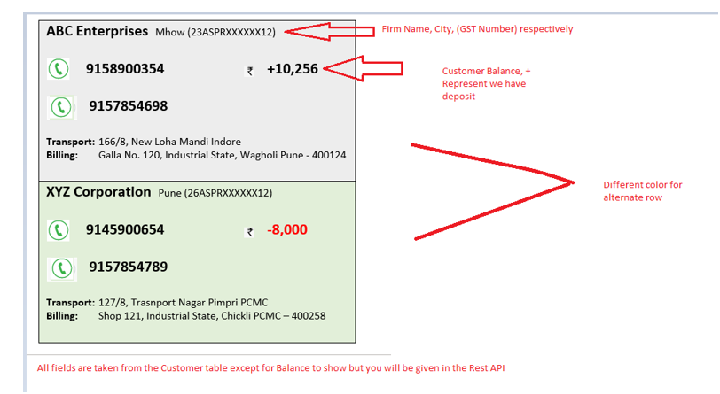

## Delivery Create

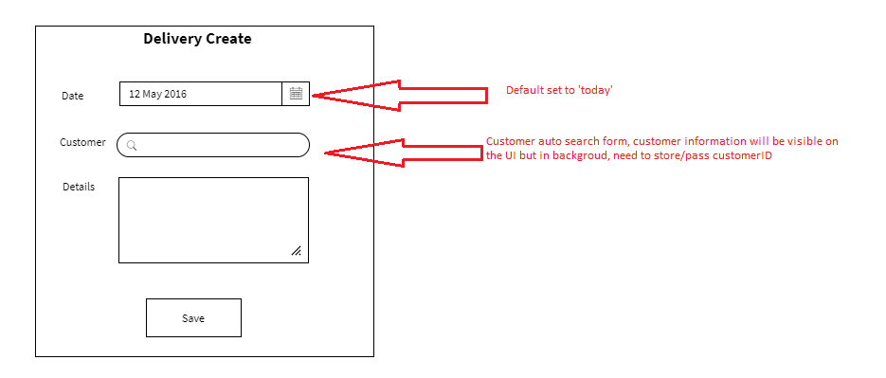

|  |  |  |
| --- | --- | --- |
| **Field** | **Validations** | **On Action** |
| Date* | Not Empty  default “today” | Save |
| Customer * | Not Empty |

|  |  |  |
| --- | --- | --- |
| **On Action** | **What to do** | **API to use** |
| Customer  Type 2 character – auto search | Search City/Village from the list |  |
| Save | Create Delivery |  |

## View/List Delivery

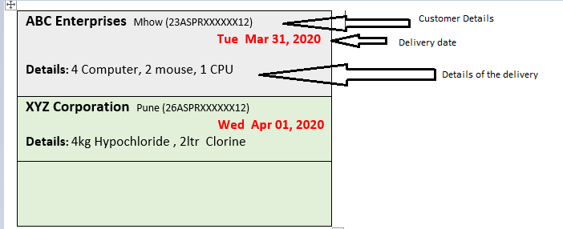

## Purchase Entry/Received-Bill Entry

The form will show basic form fields to create a bill, if a user wants to enter more details:- he can click on “Advanced”

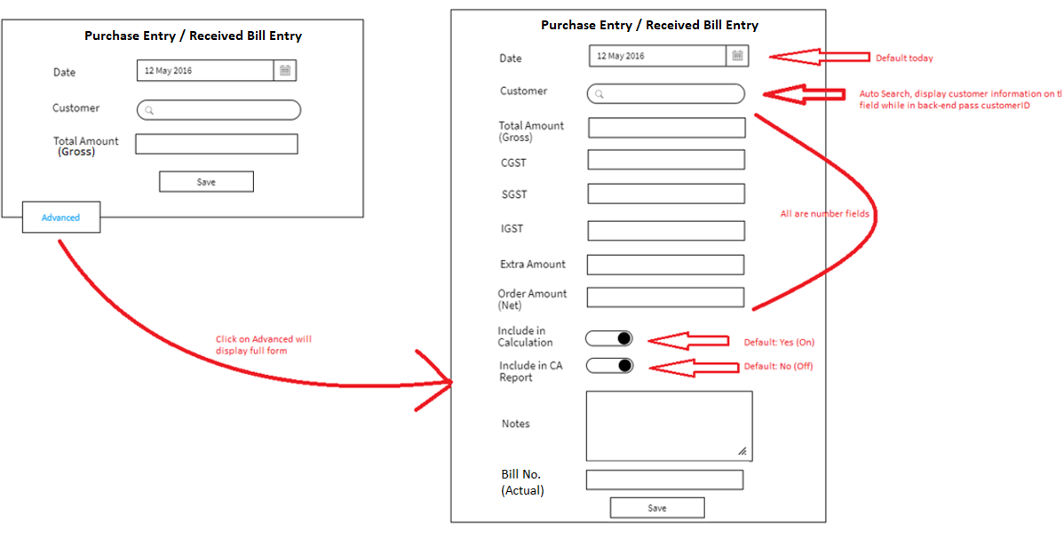

**Mandatory Fields**

Date, Customer,

**Validation:**

Number Validation (cannot be a text) :

|  |  |  |
| --- | --- | --- |
| **Field** | **Validations** | **On Action** |
| Date* | 1. Not Empty 2. default “today” | Save |
| Customer * | Not Empty |
| Total Amount (Gross) | 1.Not Empty  2.Numbers only |  |
| CGST,SGST,IGST, Extra Amount, Order Amount(Net) | If value is present, it is number. |  |

|  |  |  |
| --- | --- | --- |
| **On Action** | **What to do** | **API to use** |
| Customer Search  Type 2 character – auto search | Search Customer’s **account** (not customer actually) |  |
| Save | Create Purchase Entry |  |

## List Purchase Bill

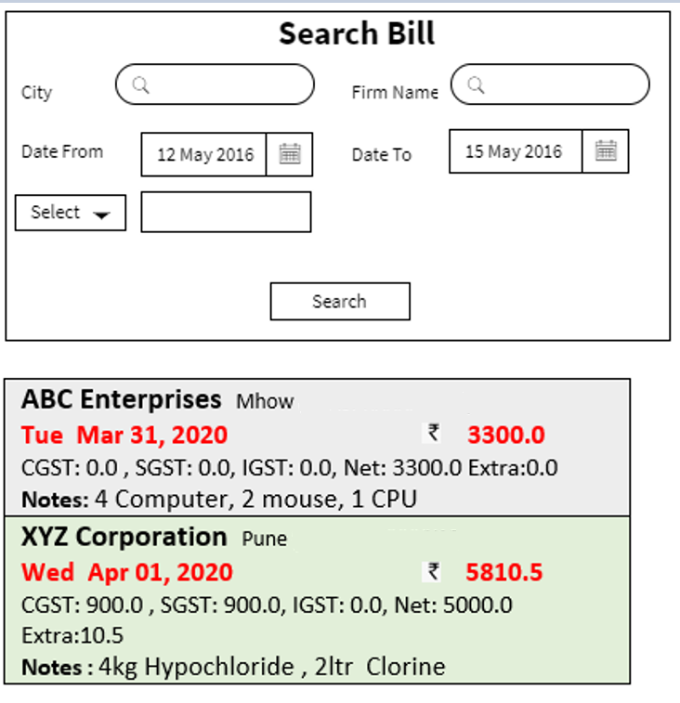

**Search Panel explaination below:**

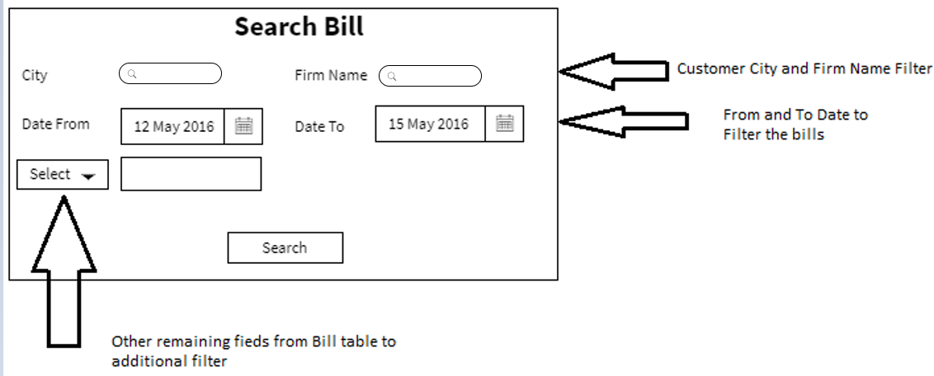

**List Panel explaination below:**

|  |
| --- |
| **ABC Enterprises** Mhow (23ASPRXXXXXX12)  **Tue Mar 31, 2020 3300.0**  CGST: 0.0 , SGST: 0.0, IGST: 0.0, Net: 3300.0 Extra:0.0  **Notes:** 4 Computer, 2 mouse, 1 CPU  **Include in CA Report: Yes**  **Include in Calculation: No**  **Bill No:** **C102** |
| **XYZ Corporation** Pune (26ASPRXXXXXX12)  **Wed Apr 01, 2020 5810.5**  CGST: 900.0 , SGST: 900.0, IGST: 0.0, Net: 5000.0 Extra:10.5  **Notes :** 4kg Hypochloride , 2ltr Clorine  **Include in CA Report: No**  **Include in Calculation: Yes**  **Bill No:** |

## Create Expense

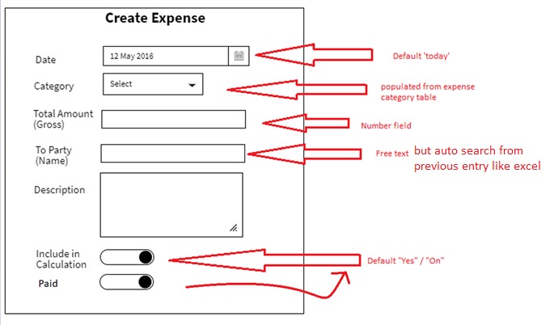

|  |  |  |
| --- | --- | --- |
| **Field** | **Validations** | **On Action** |
| Date* | 1. Not Empty 2. default “today” | Save |
| Category* | Not Empty |
| Total Amount (Gross) | 1.Not Empty  2.Numbers only |  |
| To Party (Name) | Not Empty  Atleast 3 characters |  |
| Include in calculation, Paid | Default “Yes/On” |  |
|  |  |  |

|  |  |  |
| --- | --- | --- |
| **On Action** | **What to do** | **API to use** |
| Category – List | Show Category list |  |
| Save | Create Sales Entry /Create Invoice |  |

## List/View Expense

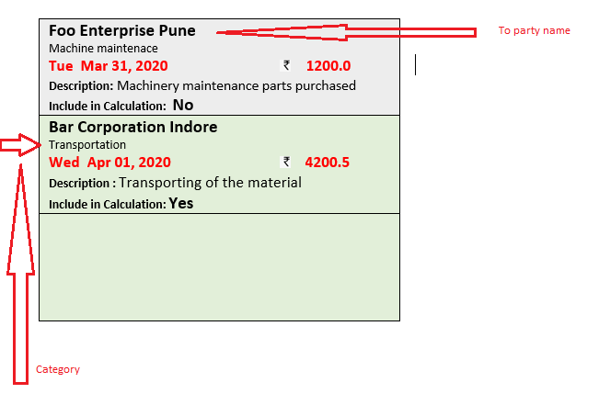

## Create Payment Received

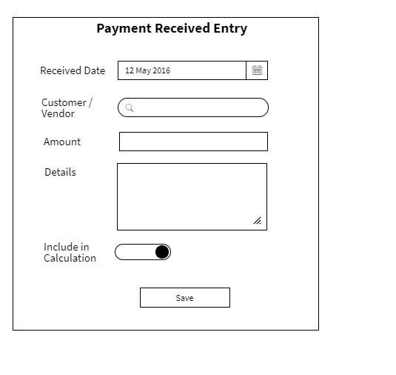

**Mandatory Fields**: Received Date, Customer/Vendor, Amount,

**Hidden Field:**

CreatedById = Logged in User ID

Received By: Account ID

**Populate UI fields:**

Customer/Vendor :

|  |  |  |
| --- | --- | --- |
| **Field** | **Validations** | **On Action** |
| Received Date* | 1. Not Empty 2. default “today” | Save |
| Customer/Vendor | Not Empty |
| Amount | 1.Not Empty  2.Numbers only |  |
|  |  |  |
| Include in calculation | Default “Yes/On” |  |
|  |  |  |

|  |  |  |
| --- | --- | --- |
| **On Action** | **What to do** | **API to use** |
| Customer/Vendor – Search | User Type 2 characters and auto-search starts and shows the list of customer’s accounts  Search on Account instead of Customer/Vendor |  |
| Save | Create a Payment Received |  |

## List Payment Received

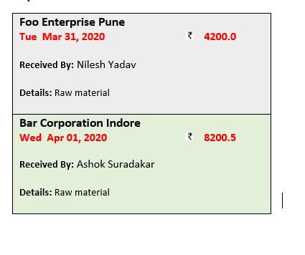

## Sales Entry / Create Invoice

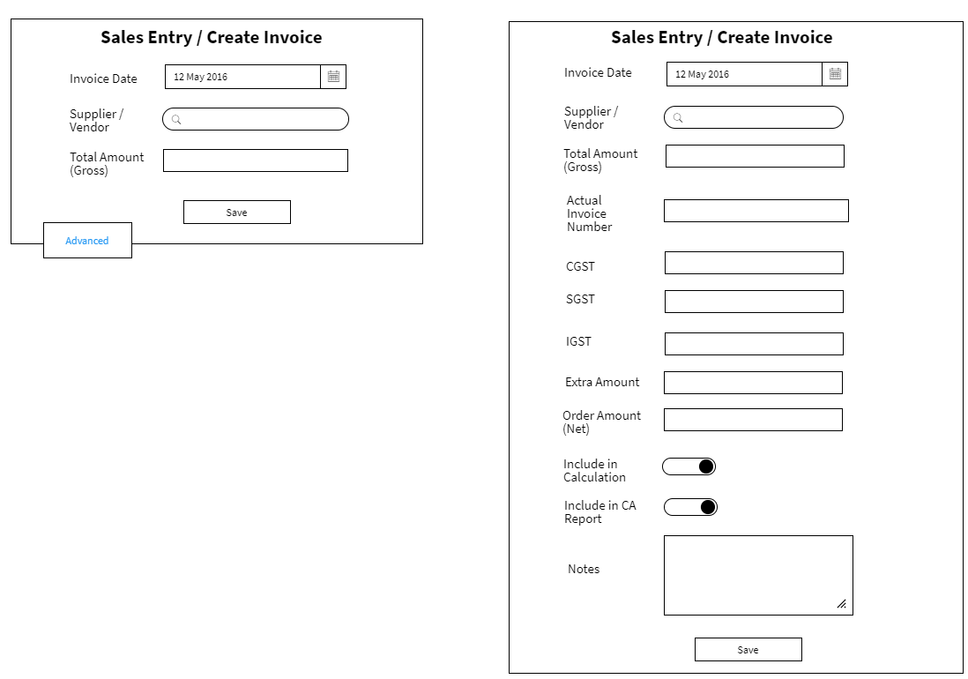

|  |  |  |
| --- | --- | --- |
| **Field** | **Validations** | **On Action** |
| Invoice Date* | 1. Not Empty 2. default “today” | Save |
| Supplier/Vendor * | Not Empty |
| Total Amount (Gross) | 1.Not Empty  2.Numbers only |  |
| CGST,SGST,IGST, Extra Amount, Order Amount(Net) | If value is present, it is number. |  |

|  |  |  |
| --- | --- | --- |
| **On Action** | **What to do** | **API to use** |
| Supplier/Vendor Search  Type 2 character – auto search | Search Customer’s **account** (not customer actually) |  |
| Save | Create Sales Entry /Create Invoice |  |

## List Sales Invoice

|  |
| --- |
| **National Chemical Ltd.** Ahmadabad  **Tue Mar 31, 2020 3300.0**  Net: 3300.0, CGST: 0.0 , SGST: 0.0, IGST: 0.0, Extra:0.0  **Notes:** 4kg Hypochloride , 2ltr Clorine  **Include in Calculation: No**  **Include in CA Report: Yes**  **Bill No: C103** |
| **Aardhya Agro Ltd** Pune  **Wed Apr 01, 2020 5810.5**  Net: 5000.0 , CGST: 900.0 , SGST: 900.0, IGST: 0.0, Extra:10.5  **Notes :** 4 Computer, 2 mouse, 1 CPU  **Include in Calculation: Yes**  **Include in CA Report: No**  **Bill No:** |

## Pay To Vendor

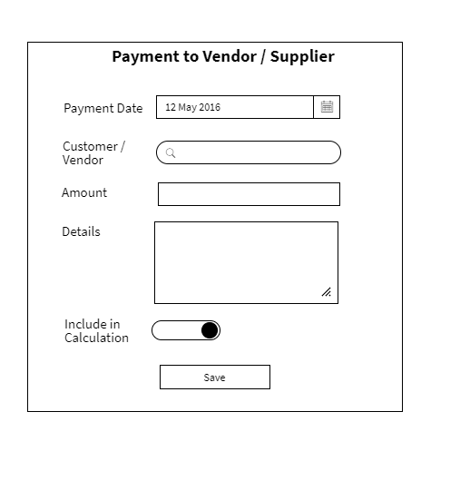

|  |  |  |
| --- | --- | --- |
| **Field** | **Validations** | **On Action** |
| Payment Date* | 1. Not Empty 2. default “today” | Save |
| Customer/Vendor | Not Empty |
| Amount | 1.Not Empty  2.Numbers only |  |
|  |  |  |
| Include in calculation | Default “Yes/On” |  |
|  |  |  |

|  |  |  |
| --- | --- | --- |
| **On Action** | **What to do** | **API to use** |
| Customer/Vendor – Search | User Type 2 characters and auto-search starts and shows the list of customer’s accounts  Search on Account instead of Customer/Vendor |  |
| Save | Create PayToVendor |  |
|  |  |  |

## List Pay To Vendor

|  |
| --- |
| **National Chemical Ltd.** Ahmadabad  **Tue Mar 31, 2020 3300.0**  **Done By:** Nilesh Yadav  **Details:** Raw material |
| **Aardhya Agro Ltd** Pune  **Wed Apr 01, 2020 5810.5**  **Done By:** Ashok Suradakar  **Details:** Raw material |

## Internal Transfer

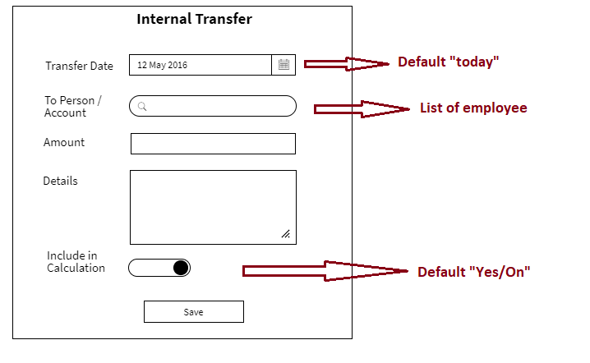

|  |  |  |
| --- | --- | --- |
| **Field** | **Validations** | **On Action** |
| Transfer Date* | 1. Not Empty 2. default “today” | Save |
| To Person/Account | Not Empty |
| Amount | 1.Not Empty  2.Numbers only |  |
|  |  |  |
| Include in calculation | Default “Yes/On” |  |
|  |  |  |

|  |  |  |
| --- | --- | --- |
| **On Action** | **What to do** | **API to use** |
| To Person/Account – Search | User Type 2 characters and auto-search starts and shows the list of employee’s accounts  Search on Account |  |
| Save | Create InternalTransfer |  |
|  |  |  |

## List Internal Transfer

|  |
| --- |
| **Tue Mar 31, 2020 4200.0**  **From:** Nilesh Yadav  **To:** Nilesh Yadav  **Details:** Galla |
| **Wed Apr 01, 2020 8200.5**  **From:** Ashok Suradakar  **To:** Avinash Yadav  **Details:** Galla |

## Create Employee

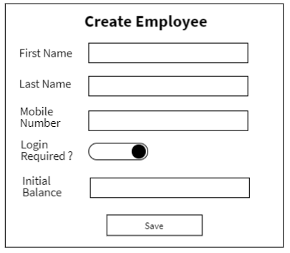

|  |  |  |
| --- | --- | --- |
| **Field** | **Validations** | **On Action** |
| First Name* | Not Empty – atleast 2 characters | Save |
| Mobile Number* | Not Empty – 10 digit number |
| Initial Balance | Number |

|  |  |  |
| --- | --- | --- |
| **On Action** | **What to do** | **API to use** |
| Save | Create Employee |  |

## List Employee

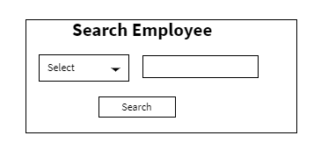

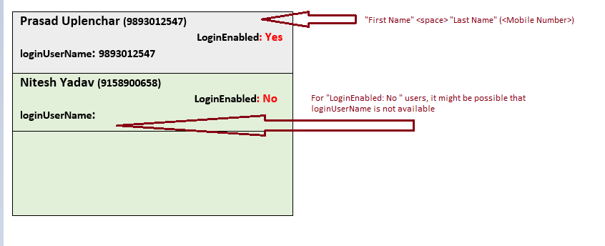

## Create Salary

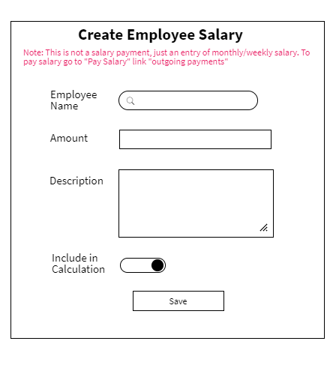

|  |  |  |
| --- | --- | --- |
| **Field** | **Validations** | **On Action** |
| Employee Name* | 1. Not Empty | Save |
| Amount | 1.Not Empty  2.Numbers only |  |
| Description | 1.Not Empty |  |
| Include in calculation | Default “Yes/On” |  |

|  |  |  |
| --- | --- | --- |
| **On Action** | **What to do** | **API to use** |
| Employee Name – Search | User Type 2 characters and auto-search starts and shows the list of employee |  |
| Save | Create an Employee |  |

## Salary Transfer

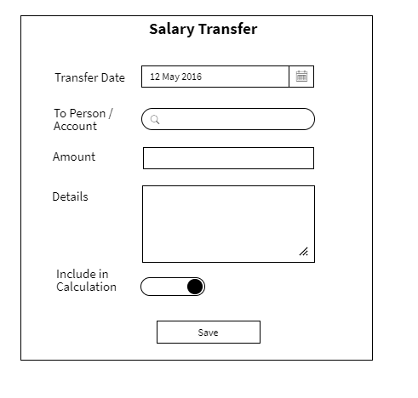

|  |  |  |
| --- | --- | --- |
| **Field** | **Validations** | **On Action** |
| Transfer Date* | 1. Not Empty 2. default “today” | Save |
| To Person / Account* | Not Empty |  |
| Amount* | 1.Not Empty  2.Numbers only |  |
| Include in calculation* | Default “Yes/On” |  |

|  |  |  |
| --- | --- | --- |
| **On Action** | **What to do** | **API to use** |
| To Person / Account – Search | User Type 2 characters and auto-search starts and shows the list of employee |  |
| Save | Create a Salary Transfer |  |

## List Salary

|  |
| --- |
| **Prasad Uplenchar (9893012547)**    **Date: Tue April 3, 2020**  **Salary: 15000.0**  **Description:** For Month of March 2020  **IncludeInCalculation:** Yes |
| **Nitesh Yadav (9158900658)**  **Date: Tue April 2, 2020**  **Salary: 15000.0**  **Description:** For Month of March 2020  **IncludeInCalculation:** Yes |

## List Salary Paid

|  |
| --- |
| **Prasad Uplenchar (9893012547)**    **Paid Date: Tue April 3, 2020**  **Amount: 15000.0**  **Paid By:** Nilesh Yadav  **Description:** For Month of March 2020  **IncludeInCalculation:** Yes |
| **Nitesh Yadav (9158900658)**  **Paid Date: Tue April 2, 2020**  **Paid Amount: 15000.0**  **Paid By:** Nilesh Yadav  **Description:** For Month of March 2020  **IncludeInCalculation:** Yes |

## Appendix

List Salary Paid

[https://wireframepro.mockflow.com/editor.jsp?editor=on&bgcolor=white&perm=Create&ptitle=Test&category=form&projectid=M2842c70ddeae32ebe7ec3bebea90bc331585569701819&publicid=45c69ca06e1a4a2292e66f6ba5efac72#/page/D53ecf8202f75dfdff308076c6b85a1cf](https://wireframepro.mockflow.com/editor.jsp?editor=on&bgcolor=white&perm=Create&ptitle=Test&category=form&projectid=M2842c70ddeae32ebe7ec3bebea90bc331585569701819&publicid=45c69ca06e1a4a2292e66f6ba5efac72" \l "/page/D53ecf8202f75dfdff308076c6b85a1cf)

|  |
| --- |
| **ABC Enterprises** Mhow (23ASPRXXXXXX12)  **9158900354 +10,256**  **9157854698**  **Transport:** 166/8, New Loha Mandi Indore  **Billing:** Galla No. 120, Industrial State, Wagholi Pune - 400124 |
| **XYZ Corporation** Pune (26ASPRXXXXXX12)  **9145900654 -8,000**  **9157854789**  **Transport:** 127/8, Trasnport Nagar Pimpri PCMC  **Billing:** Shop 121, Industrial State, Chickli PCMC – 400258 |

Delivery

|  |
| --- |
| **ABC Enterprises** Mhow (23ASPRXXXXXX12)  **Tue Mar 31, 2020**    **Details:** 4 Computer, 2 mouse, 1 CPU |
| **XYZ Corporation** Pune (26ASPRXXXXXX12)  **Wed Apr 01, 2020**  **Details:** 4kg Hypochloride , 2ltr Clorine |
|  |

**Bill**

|  |
| --- |
| **ABC Enterprises** Mhow (23ASPRXXXXXX12)  **Tue Mar 31, 2020 3300.0**  CGST: 0.0 , SGST: 0.0, IGST: 0.0, Net: 3300.0 Extra:0.0  **Notes:** 4 Computer, 2 mouse, 1 CPU  **Include in CA Report: Yes**  **Include in Calculation: No**  **Bill No:** **C102** |
| **XYZ Corporation** Pune (26ASPRXXXXXX12)  **Wed Apr 01, 2020 5810.5**  CGST: 900.0 , SGST: 900.0, IGST: 0.0, Net: 5000.0 Extra:10.5  **Notes :** 4kg Hypochloride , 2ltr Clorine  **Include in CA Report: No**  **Include in Calculation: Yes**  **Bill No:** |

Expense List:

|  |
| --- |
| **Foo Enterprise Pune**  Machine maintenace  **Tue Mar 31, 2020 1200.0**  **Description:** Machinery maintenance parts purchased  **Include in Calculation: No**  **Include in CA Report: Yes** |
| **Bar Corporation Indore**  Transportation  **Wed Apr 01, 2020 4200.5**  **Description :** Transporting of the material  **Include in Calculation: Yes**  **Include in CA Report: No** |

**Employee**

|  |
| --- |
| **Prasad Uplenchar (9893012547)**  **Company Balance : -11,000.0**  **LoginEnabled: Yes**  **loginUserName: 9893012547**  **Salary To be Paid: 9000.0** |
| **Nitesh Yadav (9158900658)**  **Company Balance: 1,9,0000.0**  **LoginEnabled: Yes**  **loginUserName: 9158900658**  **Salary To be Paid: 9000.0** |

**Payments**

|  |
| --- |
| **Foo Enterprise Pune**  **Tue Mar 31, 2020 4200.0**  **Received By:** Nilesh Yadav  **Details:** Raw material |
| **Bar Corporation Indore**  **Wed Apr 01, 2020 8200.5**  **Received By:** Ashok Suradakar  **Details:** Raw material |

List Vendor Invoices

|  |
| --- |
| **National Chemical Ltd.** Ahmadabad  **Tue Mar 31, 2020 3300.0**  Net: 3300.0, CGST: 0.0 , SGST: 0.0, IGST: 0.0, Extra:0.0  **Notes:** 4kg Hypochloride , 2ltr Clorine  **Include in Calculation: No**  **Include in CA Report: Yes**  **Bill No: C103** |
| **Aardhya Agro Ltd** Pune  **Wed Apr 01, 2020 5810.5**  Net: 5000.0 , CGST: 900.0 , SGST: 900.0, IGST: 0.0, Extra:10.5  **Notes :** 4 Computer, 2 mouse, 1 CPU  **Include in Calculation: Yes**  **Include in CA Report: No**  **Bill No:** |

List Vendor Payments

|  |
| --- |
| **National Chemical Ltd.** Ahmadabad  **Tue Mar 31, 2020 3300.0**  **Done By:** Nilesh Yadav  **Details:** Raw material |
| **Aardhya Agro Ltd** Pune  **Wed Apr 01, 2020 5810.5**  **Done By:** Ashok Suradakar  **Details:** Raw material |

List Salary

|  |
| --- |
| **Prasad Uplenchar (9893012547)**    **Date: Tue April 3, 2020**  **Salary: 15000.0**  **Description:** For Month of March 2020 |
| **Nitesh Yadav (9158900658)**  **Date: Tue April 2, 2020**  **Salary: 15000.0**  **Description:** For Month of March 2020 |

